Khari | 
Lou | 
Aviva | 
Gwen | 
Peggy | 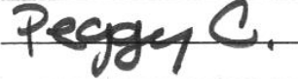
James | 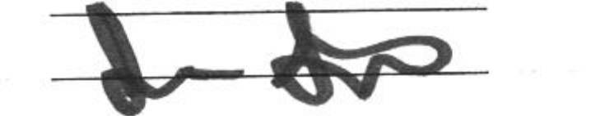
Laura | 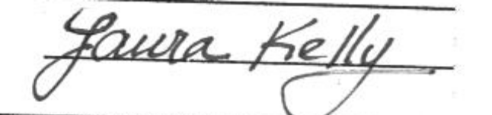
Kim | 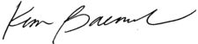
Andy Perry | 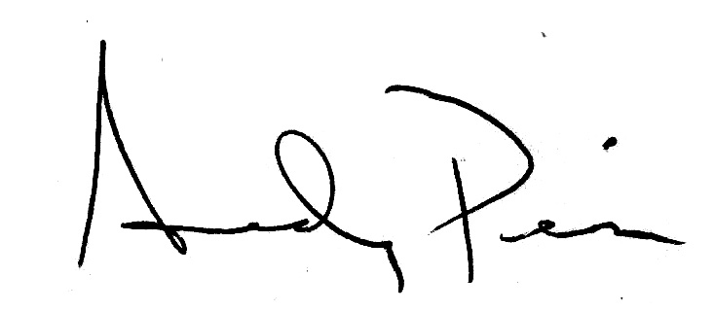
Alisha | 
heather Crawford | 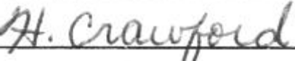
tom boss | 

Jim | 
Wendi | 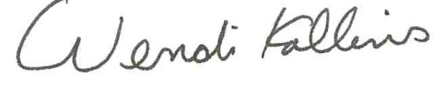
Tasmin | 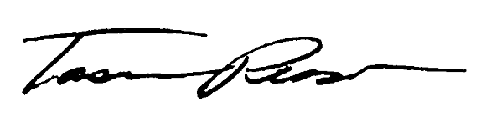
Peter | 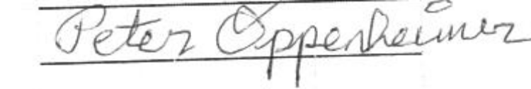
Jim | 
Taylor | 
Laura Sakamoto | 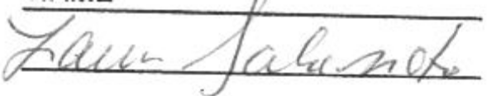
April | 